A picture containing clipart

Description generated with very high confidence

Azure 103 Module 2

Hands On - 11

Azure Certification Training

[**support@intellipaat.com**](mailto:support@intellipaat.com)

**+91-7022374614**

**US: 1-800-216-8930(Toll Free)**

**Azure 103 Module 2, Hands On – 11**

**Create and connect file shares from storage explorer.**

**Step 1:** Right click on File Shares and click on Create File Shares.

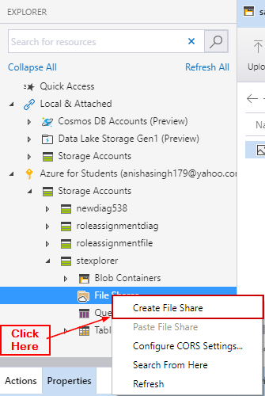

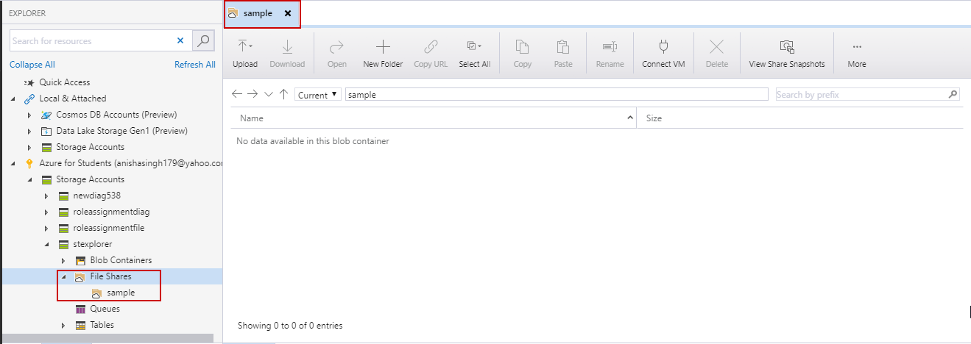

**Step 2:** Click on Connect VM and copy the command.

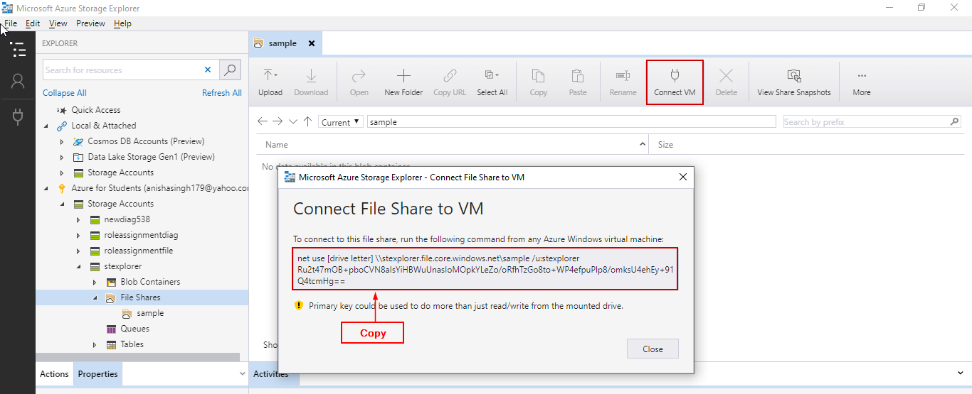

**Step 3:** Paste the command in CMD and make sure to replace the [drive letter] with the drive letter of your choice.

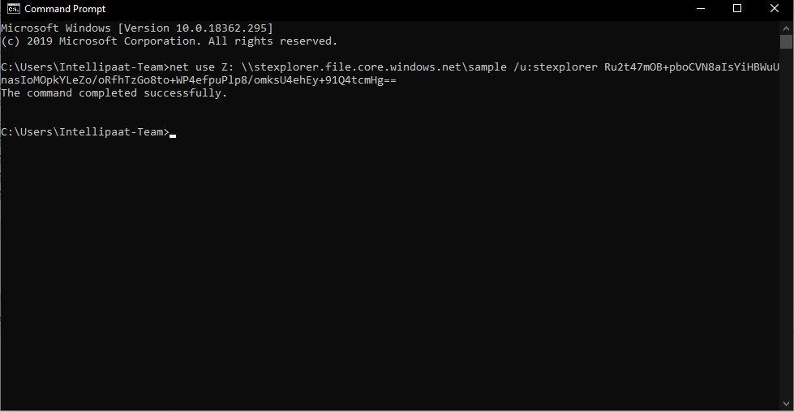

**Step 4:** Open explorer and see the mounted drive.

